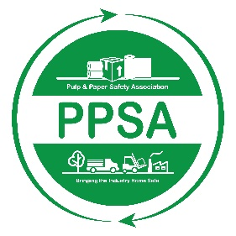

Pulp and Paper Safety Association
The Executive Eagle Nomination Form
2022-2023

This prestigious award is given each year to honor a pulp & paper industry executive that has made a significant contribution to the safety & health programs within their area or areas of direct responsibility and has a demonstrable record of support for the Pulp & Paper Safety Association.

To nominate an Executive for this award, please review the nomination procedure, complete this form and submit it along with your accompanying information via email or regular mail:

PULP & PAPER SAFETY ASSOCIATION
15 Technology Parkway South
Suite 115
Peachtree Corners, GA 30092
eragauskas@ppsa.org

ALL NOMINATIONS MUST BE RECEIVED IN THE ASSOCIATION OFFICE BY MARCH 31, 2023 FOR THE PRECEDING AWARD YEAR.

NOMINATION PROCEDURE FOR THE EXECUTIVE EAGLE AWARD

Eligibility

- To be eligible for the Executive Eagle, the nominee must be a Corporate CEO, COO, CFO, Senior Vice-President or Area, Region, Division, or Facility General Manager.

Criteria

- A member of the Pulp & Paper Safety Association must submit the nomination. The nominee must have made a significant and sustained contribution to the improvement of his or her company's safety process or culture and in some way impacted the industry. The nominee must be directly involved with, directly lead, or directly impact safety. They must also demonstrate active support of the Pulp & Paper Safety Association.
Procedure

- Nominations must be submitted and received in the Association office no later than March 31, 2023 for the preceding year's award.
- The simple nomination form must be completed, but should be accompanied by a narrative document explaining why this candidate should be chosen. The nominee's qualifications, experience, influence, involvement, education, work history and safety successes should be outlined in the narrative. You should include any additional documents, copies of previous awards or pictures to help tell the story. Remember that you are trying to promote your nominee and how he or she has been involved in safety, how they have impacted safety, how they have achieved success in safety and why they should receive the Executive Eagle. We have found that putting this material in a small 3-ring binder or in Microsoft Word and/or PowerPoint format is effective.
- When completed, mail this nomination packet directly to the Association Office via email or regular mail. Remember that it must be received by March 31, 2023.
- The Association Awards Committee will review each nomination and certify eligibility. The committee will then review each nomination with the Association Board of Directors.
- The Board will select the recipient of the Executive Eagle at the spring Directors meeting.
- The Executive Eagle Award will be presented each year at the Pulp & Paper Safety Association's Professional Development Conference.

Nomination Form for the Executive Eagle Award:

Year: 2022

Nominee:

Title:

Company:

Address:

Phone:

Length of time at current position:

Submitted by:

Submit Narrative and supporting information as described in procedures above.

