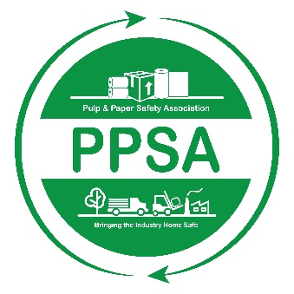

Pulp and Paper Safety Association
Safety Leader of the Year Award
2022-2023

The PPSA would like to recognize outstanding achievement within the safety profession with the Safety Leader of the Year (SLY) Award. The SLY Award recognizes a single forest products industry leader who has demonstrated unique, engaging and effective approaches to the safety programs within their company. In doing so, this individual has had a profound and positive impact on safety within the forest products industry.

Eligibility: in order to qualify the individual must meet the following criteria:

- The individual’s site or company must be an active member of the PPSA.
- The individual must be a full-time employee in a leadership role (i.e. safety professional, lead worker, safety committee member, etc.) who is involved with their company’s safety efforts.
- The individual is not currently serving on the PPSA Board of Directors.
- Executive Eagle Award winners are not eligible.

Nomination: An individual meeting the eligibility requirements noted above can be nominated by a co-worker by completing the PPSA- Safety Leader of the Year Award: Nomination Form. This form is available on-line at www.ppsa.org. Applications must be submitted electronically to the PPSA Member Relations Manager by March 31, 2023 at ERagauskas@ppsa.org.

ALL NOMINATIONS MUST BE RECEIVED IN THE ASSOCIATION OFFICE BY MARCH 31, 2023.

Safety Leader of the Year Award
Nomination Form

This form can be completed by any co-worker or associate (herein after referred to as the Sponsor) of the Nominee.

Sponsor Information:
Name:
Address:
Phone:
Email:
Title:
Company Name:

Nominee Information:
Name:
Address:
Phone:
Email:
Title:
Company Name:

Attachments: the following information regarding the nominee shall be provided:
- Nominee’s Organization Chart; and
- Written description of the nominee’s current job/position; and
- Nominee’s resume or other document outlining their professional background; and
- A petition of the nominee’s achievements, influence and impact on safety within the forest products industry. The petition shall be submitted typed on 8.5 x 11 inch paper.
- Letter of support from nominee’s supervisor

All applications submitted by March 31, 2023 will be reviewed by the PPSA Board of Directors. A winner will be chosen and the SLY Award will be presented at the 2023 PPSA Safety and Health Conference.

