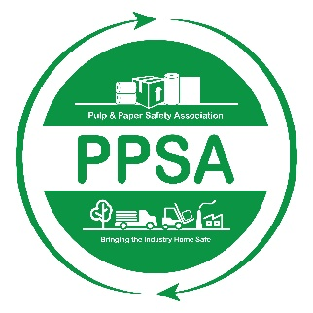

Pulp and Paper Safety Association
Industry Safety Committee/Team Award
2023-2024

This award honors a pulp & paper industry safety committee/team that has made a significant contribution to safety & health at their location, company, or within the industry. In order to receive this award, a committee/team must apply for it, be selected as a finalist by the PPSA awards committee and lastly receive the most votes by attendees and a panel. The winning site will receive the Industry Safety Committee/Team Award trophy and be highlighted on the PPSA website and upcoming quarterly report.

To apply for this award, please complete this form and submit it along with your accompanying information via email or regular mail no later than May 10, 2024:

PULP & PAPER SAFETY ASSOCIATION
15 Technology Parkway South
Suite 115
Peachtree Corners, GA 30092
hpeterson@ppsa.org

Eligibility:

- Submitting facility must be a PPSA member site at the time of submission of this application. Go to ppsa.org to become a member!

- All applicants must agree to share their submission with the PPSA membership regardless if they are selected as a finalist. PPSA will honor and share any copyright and/or patent information.

- A committee/team is eligible to apply for the award every three years.

ALL NOMINATIONS MUST BE RECEIVED IN THE ASSOCIATION OFFICE BY MAY 10, 2024 FOR THE PRECEDING AWARD YEAR.

Industry Safety Committee/Team Award
APPLICATION FORM

Please complete the following:

Committee/team being nominated:

How many are on the committee/team:
Company:

Address:

Phone:

Email:
__________________________________________________________________________________

Your name:

Company:

Your job title:

Address:

Phone:

Email:
__________________________________________________________________________________
Specific Information for the Safety Committee/Team Award
Please include with this form the following information: (Be as specific as possible. Nominations are judged on the information you submit.)
- Provide the mission statement or charter of the safety committee/team you are nominating.
- Provide the minutes and agendas for the safety committee/team meetings held in the past six months.
- Describe some of the safety committee/team's accomplishments, projects, or recommendations that have significant impact on the safety and health of workers.
- Describe any innovative activities the safety committee/team has engaged in.
- Describe any activities taken place to involve non-committee employee engagement.

